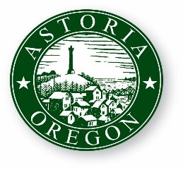
AGENDA

ASTORIA CITY COUNCIL WORK SESSION
Monday, February 25, 2019
8:00 AM
2nd Floor Council Chambers
1095 Duane Street Astoria OR 97103

- CALL TO ORDER

- ROLL CALL

- CITY COUNCIL GOAL SETTING
- ADJOURNMENT

